1.DATASET

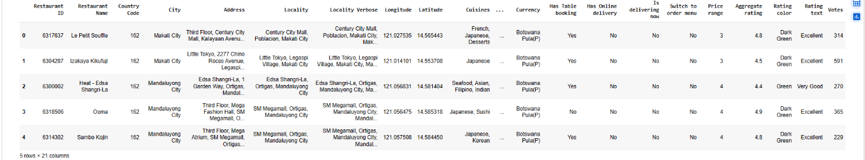

Step 1: Rename Important Columns
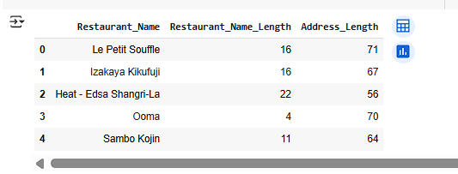

Step 2: Extract New Features

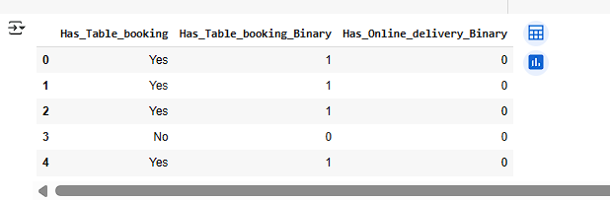

Step 3: Optional — Combine or Engineer More Features
